**2PI- ‘Parts of a Story’ Scavenger Hunt Name:**

Before you can create a comic, you must develop a story. Complete this online scavenger hunt to learn all the necessary parts of a story. To complete this handout you will need to read all directions carefully and follow links through our website.

To begin, go to our class website at [www.kmyersenglish.weebly.com](http://www.kmyersenglish.weebly.com)

Click on the following links to find the necessary information.

**C:\Users\Jenna\AppData\Local\Microsoft\Windows\Temporary Internet Files\Content.IE5\K6Q7957V\MC900078795[1].wmfCHARACTERS:**

* A character is: (copy the first definition)

**1)** _________________________________________________

**2)  The characteristics of a person.**

* There are 2 main types of characters in stories.

**A) Protagonist**

Definition:_______________________________________________

**B) Antagonist**

Definition:_______________________________________________

* In the story of Batman, who is the:

Protagonist: Antagonist:

**SETTING:**

* C:\Users\Jenna\AppData\Local\Microsoft\Windows\Temporary Internet Files\Content.IE5\K6Q7957V\MC900036731[1].wmfA setting is (copy the definition):

______________________________________________________________________________________________________________________________

* There are 5 aspects that help develop a plot. List them below:

1) ____________________

2) ____________________

3) ____________________

4) ____________________

5) ____________________

**PLOT:**

* The plot is how the author arranges events to develop his basic idea; it is the sequence of events in a story or play.

A plot must have 5 parts. Label the plot parts below, and give a brief description of each part.

C) _________________________

B) __________________

__________________

A) __________________

D) __________________

_________________

E) __________________

**CONFLICT:**

* It is the opposition of forces which ties one incident to another and makes the plot move.  Conflict is not merely arguments; it is any form of opposition that faces the main character.

There are many different types of conflict. List the 5 other types below, and then think of a movie, book or show that is an example of that conflict type. *Note: Supernatural and God/ Fate has been combined.

|  |  |  |
| --- | --- | --- |
| **1)**  **Person vs. Supernatural/ God**  Ex. Film: Independence Day | 2) | 3) |
| 4) | 5) | 6) |

**POINT OF VIEW**

* Point of view, or p.o.v., is defined as the angle from which the story is told.

**1) First Person:**

The narrator is usually the ________________, where the narrator refers to him or herself as _________________.

**2) Second Person:**

________________________________________________________________________________________________________

**3) Third Person:**

Where the narrator refers to characters as _____________________________________________, but never as ________.

**THEME**

* The theme of a story is:

____________________________________________________________________________________________________________________________________________________________

Remember, an author does not always tell us the theme directly; sometimes the reader has to discover it on their own.

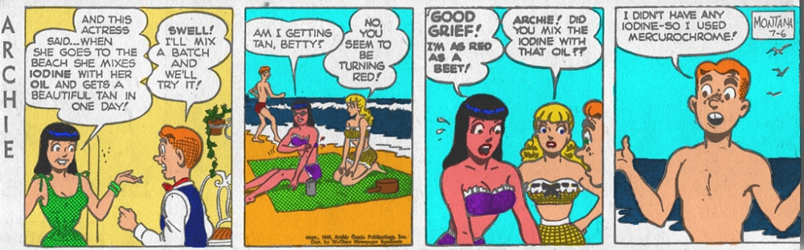

Read the Archie comic strip above. What is the ‘theme’ of this comic? Does the author teach the reader a lesson through this example? Explain:

________________________________________________________________________________________________________________________________________________________________________________________________________________