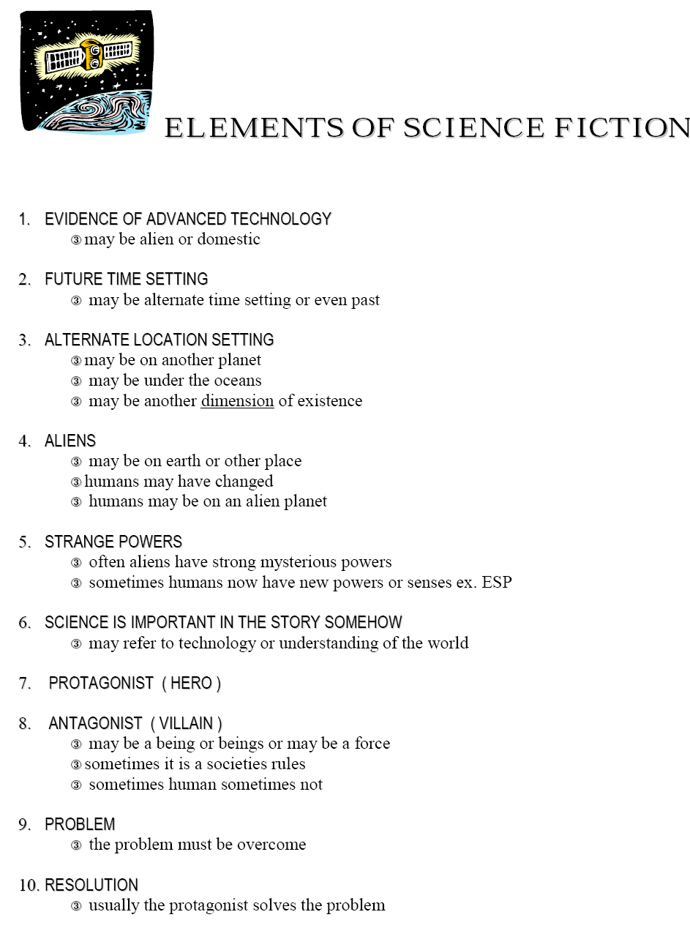

From http://laurier.vsb.bc.ca/students/scifiels.pdf

