COMIC STRIP
‘Terms to Know’
What is a Comic Strip?

An amusing short story or situation portrayed in a series of pictures with limited text. A comic strip is typically funny, but can be sarcastic, ironic etc.

What are the parts of a comic strip?

Panel: A single ‘picture box’ in a comic. Each panel represents one part of the story, and an effective comic should have a minimum of 5 panels (one to represent each part of the story).

Gutter: The white borders that surround and divide panels. These borders tell the reader that each panel is a different part of the story.

Cartoon Character(s): Any character portrayed in a fictional (cartoon) form.

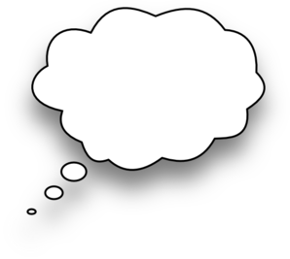
Motion Lines: Are lines drawn beside characters or objects that indicate the speed and direction of their movement.

Speech Bubbles/balloons: A balloon shape extending from a character that shows what they are saying. The speech bubble must have a ‘tail’ that connects to the speaker.

Thought Bubble (balloon): A balloon shape extending from a character that shows what they are thinking. *The style of thought bubbles need to look different from speech bubble in font and style.

Word Art: Enlarged words (onomatopoeia) that emphasize sound effects.

Captions: Captions give information from an unknown narrator, but they are not spoken from a character. The captions are usually in a rectangular text box, not a bubble.

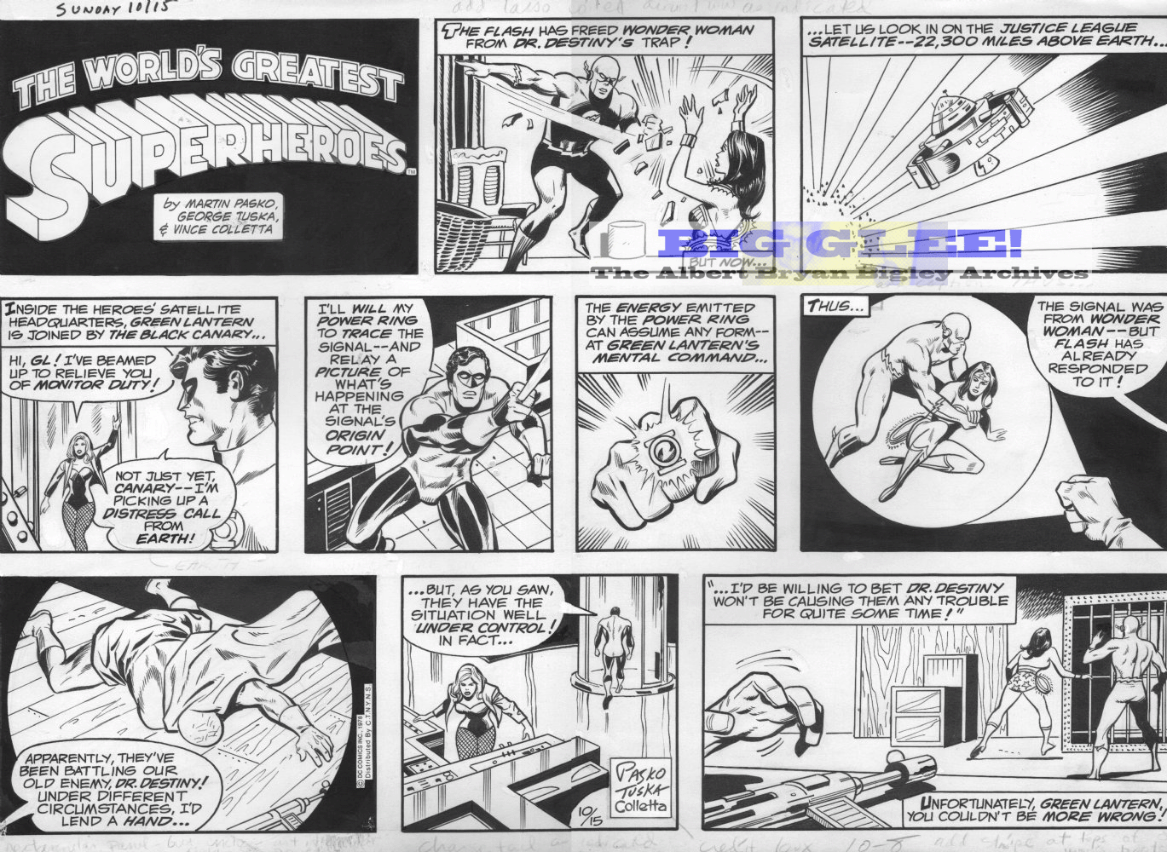

- Draw an arrow to the gutter
- Circle the third panel
- Highlight the comic narrative
- Colour 2 speech bubbles
- Add a final comic panel that includes word art
- Identify one cartoon character: __________________
- Circle one thought bubble, and add an additional thought bubble

