After you have considered how to write the various parts of a news report, you will practice creating your very own story.

Photo 1)

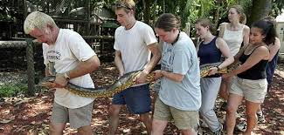
Create a headline for a story focused on this image…

Photo 2)

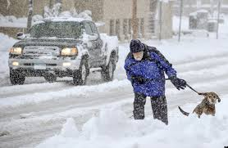
Create a caption focused on this image…

Photo 3)

Create a lead focused on this image…  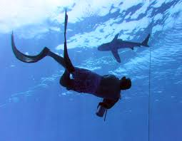 | WHO:  WHAT:  WHEN:  WHERE:  WHY:  HOW?
Now, write one complete sentence that incorporates the 5W’s. This is your lead!

Photo 4)

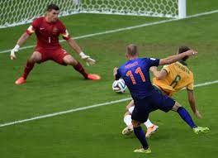  Create a quote spoken by a bystander focused on this image… | Who:  Relation to story:  “  “.

Using the headline provided, brainstorm the other details and necessary parts. You will then work with a team of 3 to write your complete news report.

Brainstorming!
Masthead
Headline | ECI English Teacher Disappearance: Students Suspected
Byline
Dateline
Lead | Remember to include the 5W’s in one sentence!
Body | List 6 additional facts that would be included in the story…
Quotations | List two quotations spoken by people impacted by your story
Image | 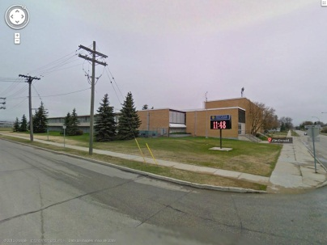
Caption

