**[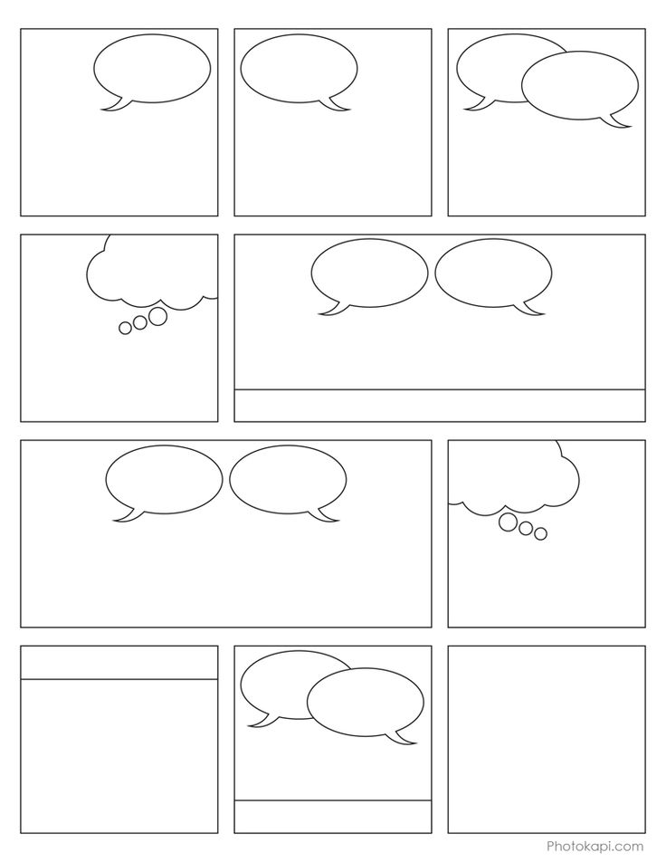](http://photokapi.com/2013/03/comic-book-panels/)**