When it comes to seeing a logo that makes you wonder, “Why didn’t I think of that?” what is it about the design that gives that impression?
Logos
There are five important design elements when it comes to brand identities. Iconic logos are:
- Describable (Ex: Pepsi ball, red, white and blue curved lines)
- Memorable (Ex: McDonald’s golden arches)
- Effective without colour (Ex: Adidas)
- Scalable i.e. work when just an inch in size (Ex: Nike Swoosh)
- Relevant to the industry in question (Ex: Mac’s silver apple)
Points one and two go hand-in-hand, because if you can’t describe what a logo looks like then how will you be able to remember it?
Point number three is important because colour is secondary to the shape and form. I always leave colour to the end of the design process, because if the mark doesn’t work in black only, no amount of colour will rescue it.
Point number four is vital for making money, such as office stationery (pens, pin badges etc.) — all those little things that can easily be overlooked.
Lastly, the design must be relevant for the business it identifies. This is accomplished through in depth research into the industry involved, and helps to differentiate from closely associated competitors.
Here’s a logo to illustrate the five points:
The above logo is for Open University (OU), “the UK’s leading distance-learning organization.”
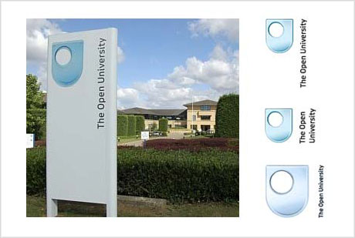
What is successful about this design is the simplicity (the ‘O’ inside the ‘U’). The OU logo has evolved over the years, and didn’t always have the ‘glass’ effect—a common trend amongst today’s logos. It’s important to remember, however, that trends don’t last, and by designing using the latest fad, your logo will become dated, fast.
Take a look at how the OU logo appeared in the past (below).
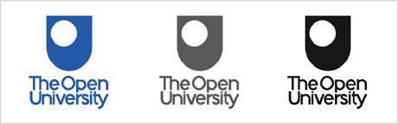
The design leaves a little to be desired, but the same distinctive, memorable, scalable, describable, reproducible mark was used to set the Open University apart from its competitors.

Do you have a favourite logo that uses these five universal elements?

Now is your chance to create a logo of your own!

Use the initials of your first and last name to design a logo for a product you are marketing. It can be from an industry of your choice, for a clothing label, a restaurant, food product, sports equipment, etc. Have a product in mind and then design a logo that would be appropriate. Use the 5 elements described above to help you. Once you have finished, answer the following questions:
Product:________________________________________________________

- Describe your logo.

- What part of your logo design would make it memorable?

- If your logo effective without colour and can its scale be easily changed? Explain.

- What industry have you designed your logo for? (Sports, food, fashion, entertainment, etc.) In other words, what type of product will this logo be used for? How is your logo relevant to this industry/product?

