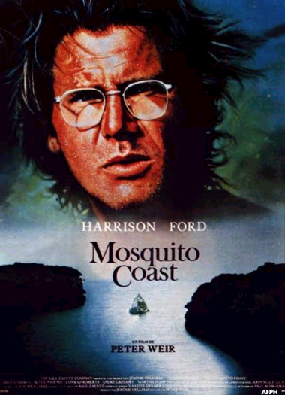
How far should a man go to find his dream.
Allie Fox went to the Mosquito Coast. He went too far.

Cast
Harrison Ford .... Allie Fox
Helen Mirren .... Mother Fox
River Phoenix .... Charlie Fox
Conrad Roberts .... Mr. Haddy
Andre Gregory .... Rev. Spellgood
Martha Plimpton .... Emily Spellgood Dick O'Neill .... Mr. Polski
Jadrien Steele .... Jerry Fox

Answer the following questions in sentences on a separate lined sheet. You may use the space on this page for rough notes but you may not submit them as your answers.

- What has made Allie Fox so disillusioned with life in America? What does he hope to accomplish by moving his family to the Mosquito Coast?

- How has Allie transformed the jungle abode of Jeronimo into his own little Utopia? Describe the way he has changed the jungle into his own little perfect world.

- Ironically, how has Allie’s mission to bring ice to the jungle turn into a catastrophe for Jeronimo?

- Why do you suppose Mother Fox never challenges her husband’s authority? Is she just as responsible for the tragic events that occur as Allie is?

- How does Reverend Spellgood’s mission also contribute to the conflict and Allie’s downfall? Consider his actions early in the story and again at the end.

Extended Paragraph Style Response (Complete the following in a 2-3 paragraph answer.)

- What went wrong? What do you think was more responsible for Allie’s failure: external forces that were against him or flaws in his own character? Trace what you consider to be the main reasons for the failure of Allie’s dream. Do you think it could have been possible for Allie’s utopia to flourish? Explain your choice.

Mark: /50

Criteria | Level 1 | Level 2 | Level 3 | Level 4
Knowledge/  Understanding  • topics and themes | ❑ deals with topics and themes with limited understanding and depth | ❑ deals with topics and themes with some understanding and depth | ❑ deals with topics and themes with considerable understanding and depth | ❑ deals with topics and themes with a high degree of insight and depth
 | ❑ covers some aspects of project with limited understanding of material | ❑ somewhat covers many aspects of project with some understanding | ❑ covers all aspects of project with considerable understanding | ❑ thoroughly covers all aspects of project with exceptional understanding
• information and ideas  /10 | ❑ includes limited relevant information and ideas | ❑ includes some relevant information and ideas to develop chosen topics | ❑ includes considerable relevant information and ideas to develop chosen topics | ❑ includes a high degree of well-chosen information and ideas to develop chosen topics
Thinking/Inquiry  • critical analysis  /10 | ❑ critically explores and analyzes topics and experiences with limited effectiveness | ❑ critically explores and analyzes topics and experiences with some effectiveness | ❑ critically explores and analyzes topics and experiences with considerable effectiveness | ❑ critically explores and analyzes topics and experiences with a high degree of effectiveness
Communication  /10 | ❑ focuses and organizes material with limited clarity and logic | ❑ focuses and organizes material with some clarity and logic | ❑ focuses and organizes material with considerable clarity and logic | ❑ effectively focuses / organizes material with a high degree of clarity, logic.
 | ❑ offers limited description and detail and few examples | ❑ offers some description, detail, and examples | ❑ offers considerable description and detail and effective examples | ❑ offers vivid description, convincing detail, and effective examples
Application

• language conventions  /10 | ❑ applies grammar, usage, spelling, and punctuation with limited accuracy and effectiveness | ❑ applies grammar, usage, spelling, and punctuation with some accuracy and effectiveness | ❑ applies grammar, usage, spelling, and punctuation with considerable accuracy and effectiveness | ❑ applies grammar, usage, spelling, and punctuation with a high degree of accuracy and effectiveness

CONFERNCE CHECKLIST /10
- arrived on-time, prepared for the conference
- all elements of the assignment are complete
- spoke with confidence and clarity
- –
- –

COMMENTS

