Rabbit Proof Fence Terminology

‘Stolen Generation’
It is estimated that 100,000 Indigenous children were taken from their families and raised in homes or adopted by white families up until the late 1960’s without parental consent. These children became known as the ‘Stolen Generations’.
Forced Removal
From 1909 until 1969, there was an official government policy mandated by the Aborigines Protection Board (APB) to remove Aboriginal children without parental consent and without a court order. Children could be put into an institution or mission dormitory, fostered or adopted by white families.
Domestic Servants
Aboriginal children were expected to become labourers or servants, so in general the education they were provided was very poor. Aboriginal girls in particular were sent to homes established by the Board to be trained in domestic service. Reports have found that members of the Stolen Generations suffered higher rates of sexual abuse, maltreatment, dislocation of family life, poverty and hardship than other Aboriginal people.
Assimilation
The goal was to assimilate or breed out Aboriginal people and teach them the European way. The lack of understanding and respect for Aboriginal people also meant that many people who supported the child removals believed that they were doing the ‘right thing’. Some people believed that Aboriginal people lived poor and unrewarding lives, and that institutions would provide a positive environment in which Aboriginal people could better themselves.
Half-Caste
An offensive term used for the offspring of parents of different races or cultures.

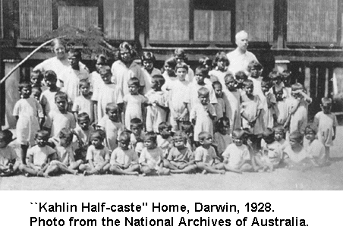
Published in a Darwin newspaper in the 1930s this picture signifies the suffering caused by the inherent racism of the Australian government's Aboriginal assimilation policies. The presents the children are holding were most likely only provided for the sake of the photograph.
The caption reads: A group of tiny half-caste and quadroon children at the Darwin half-caste home. The Minister for the Interior (Mr. Perkins) recently appealed to charitable organizations in Melbourne and Sydney to find homes for the children and rescue them from becoming outcasts.
