24 October 2012 18:15 | By Hugh Wilson, contributor, MSN Him
HMV bans staff tattoos and long hair
HMV has banned ‘extreme body art’ on employees. Was it right to do so?

Another day, another story about tattoos in the workplace.
Last week it was reported that the Metropolitan Police were banning officers from displaying visible tattoos. Today, it’s entertainment retailer HMV’s turn. According to reports, the company has told employees that, although discreet tattoos are allowable, “extreme body art” has to be covered up or removed.
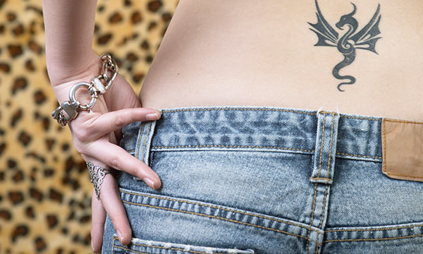
In fact, HMV goes further than that. In what the Sun describes, with typical understatement, as a “staggering” new appearance policy, the company has said it expects “high standards of personal grooming” from employees, which also means the removal of prominent piercings.
Flip-flops and open-toed sandals have also been banned, while trainers have to be neat and clean. Men must wear blue denim jeans to work.
So is HMV right to impose these stringent grooming guidelines, or are they turning their employees into clones? We look at both sides of the argument.
If staff tattoos are discreetly located it shouldn't be a problem
Employees should be well groomed
Needless to say, HMV thinks its appearance policy has the balance between personal expression and shop floor professionalism about right.
“It goes without saying that we want our work colleagues to feel valued as individuals who can express their personalities, but it’s also important that we balance this against the needs and expectations of our customers, who, ultimately, have to be at the heart of everything we do,” the company said in a statement.
And it’s certainly true that the company has every right to impose the new standards. According to employment law experts Thompsons, it is perfectly legitimate for employers to tell employees to dress in a certain way, as long as rules apply equally to both sexes.
The same is true of tattoos and body art. Employers are perfectly within their rights to ask workers to cover them up. Earlier this year, former Next sales assistant David Bruce, who has 80 tattoos, made the papers when he claimed bosses had forced him to work in the stockroom because of his body art, and asked him to cover up visible tattoos with make-up.
And the Daily Mail reported in July 2011 that a woman was refused a cleaner's job at Iceland Foods because of a tattoo on her hand.

In other words, being well groomed is still considered important in the majority of workplaces. According to economics professor Dr Gordon Patzer, author of Why Physically Attractive People Are More Successful, research suggests that neat, tidy, well-groomed men are judged to be more talented, honest and intelligent - and that’s exactly what your employer is looking for.
HMV has gone too far
So HMV are within their rights to impose their new appearance policy, and many other companies demand similar standards from their staff. But that doesn’t mean HMV has acted wisely.
Some people have already said that, in one fell swoop, HMV has lost any rock and roll credibility it still possessed. HMV is not Next or Iceland, they say. It’s a shop that sells the works of Keith Richards, Rihanna and Black Sabbath, to name a random three.
It’s meant to be selling cool, in other words, and nobody can deny that tattoos and piercings are the height of fashion right now.
In fact, one-fifth of the adult population of the UK has been inked, and among 16- to 44-year-olds - the age group most likely to be getting jobs in shops like HMV - the figure rises to 29%. A decade ago, there were 300 tattoo parlours in Britain; now the estimate is 1,500-plus.
In other words, tattoos - often large and noticeable - are becoming the norm, and the people most likely to display body art - both tattoos and piercings - are exactly the sort of people HMV needs to attract through their doors. It may be more likely to do that if some of its staff look the part too.
Other parts of the new dress code may also be out of line with the company image - or at least the image you'd think a company like HMV would like to project.
In summertime, for example, sandals are often happily tolerated, in younger, cooler workplaces. “In some workplaces they’re perfectly acceptable,” says men’s style expert Sarah Gilfillan of Sartoria Lab, “if you can wear a more casual look.”
Instead, the insistence on neat trainers and blue denim is starting to look like a uniform, an image many people may feel is the last thing a cool, happening record shop wants to promote.
Do you need to be neat and tidy for work?
Most of us know that we have to look the part for our job. If we work in a solicitor’s office, that may well mean a suit and tie. If we work on the factory floor, scruffy clothes are entirely appropriate.
And a CD, DVD and games shop? That’s somewhere out on its own. HMV bosses clearly think that, as a high street retailer, an appropriate look for their shop floor staff is towards the smarter end of casual.
Many of their customers, on the other hand, may feel more confident being served by shop assistants whose passion for popular entertainment is evidenced by large tattoos, obvious piercings or trainers that are not scrubbed clean. The publicity that has accompanied HMV’s new appearance code might turn those customers away.

